Indian Elementary School Data Analysis – Summary
The project titled “Indian Elementary School Data Analysis” focuses on understanding the overall performance of India’s elementary education system through data-driven insights. The main objective of this analysis was to examine state-wise enrollment of boys and girls, observe attendance and dropout patterns, and identify the key differences between rural and urban schools. The study also aimed to provide recommendations to improve education quality and equity across regions.
Objectives
- Examine state-wise enrollment of boys and girls.
- Identify attendance patterns and dropout rates.
- Highlight differences between rural and urban schools.
- Recommend strategies for better educational performance.

The data was cleaned by removing missing or null values to ensure consistency and accuracy. District and state names were standardized, and the data was grouped by state, gender, and school type. Additional calculated columns were created to measure dropout percentages and attendance rates. The analysis was carried out using Microsoft Excel and Power BI, which helped in transforming and visualizing the data effectively.
Data & Tools
The dataset was cleaned by removing missing values, standardizing names, and grouping by state, gender, and school type. Calculated columns were created for dropout percentages and attendance rates.
Tools used: Microsoft Excel and Power BI.
Methodology
Data was imported and transformed in Power BI to create interactive visuals and perform comparative analysis. Key visuals included:
- Bar Chart: Enrollment by state (boys vs. girls).
- Line Chart: Trends in enrollment and dropouts over time.
- Map Visual: State-wise distribution of schools and students.
- Stacked Chart: Attendance comparison (rural vs. urban).

Key Insights
- Kerala and Himachal Pradesh performed best in enrollment and attendance.
- Rural areas lag in teacher availability and attendance.
- Female enrollment has improved but still varies across states.
- Persistent challenges exist in underdeveloped regions.
The analysis revealed that Kerala and Himachal Pradesh performed exceptionally well in terms of enrollment and attendance, reflecting their stronger education systems. However, rural regions across several states continue to face challenges such as low attendance and limited teacher availability. Female enrollment has shown significant improvement, though gender disparities still exist in some parts of the country.
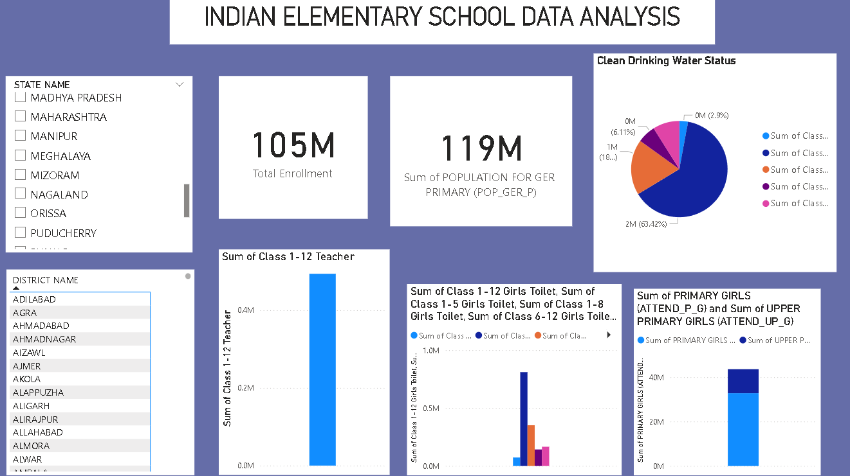
In conclusion, the study highlights that India has made considerable progress in expanding access to elementary education. Yet, issues like poor attendance and higher dropout rates in rural and underdeveloped areas persist. The narrowing gap between boys’ and girls’ enrollment indicates positive change, but achieving complete equality requires ongoing efforts. Improving school infrastructure, enhancing teacher training, and promoting community awareness are key steps toward ensuring that every child in India receives equal access to quality elementary education.

